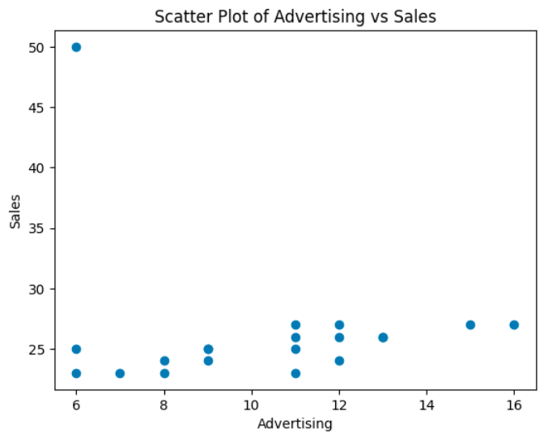

The data suggests a general positive slope, indicating that higher advertising spending is associated with higher sales.

There is a strong outlier that will definitely affect the best fit line, and we will deal with the outlier later by removing it.

By using a gradient descent approach, the following parameter values are found:

Weight (w): -0.3223570973273493

Bias (b): 29.602425638572946

Standard Error of weight: 0.45891129651800133

T-value of weight: -0.7024387932335513

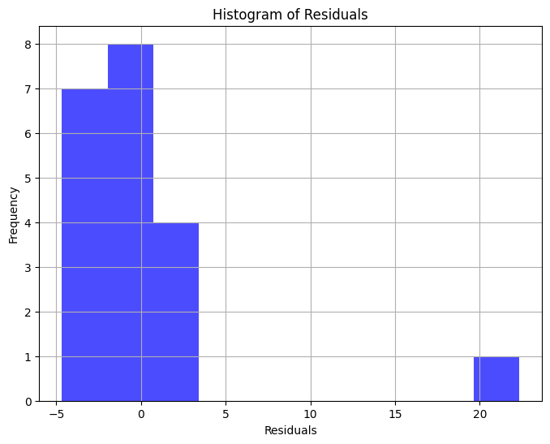

The histogram of the residuals indicate that the outliers are influencing the fit of the regression model disproportionately, aswell as a right-skewed distribution that indicates the model to be underpredicting some data points. Also, the t value and the standard error indicates that the regression isn’t precise.

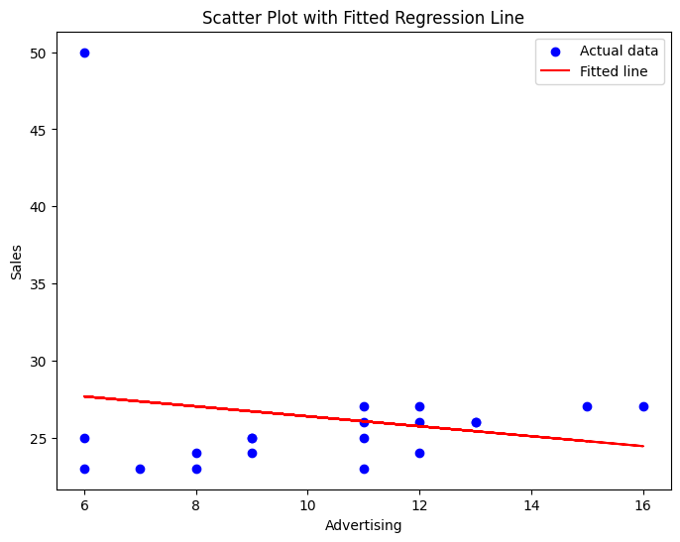

To deal with this outlier, it is removed. After that, the optimal b and a values are computed through gradient descent

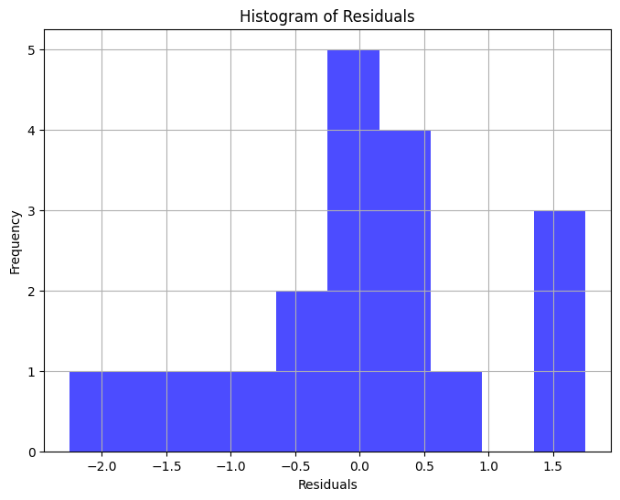

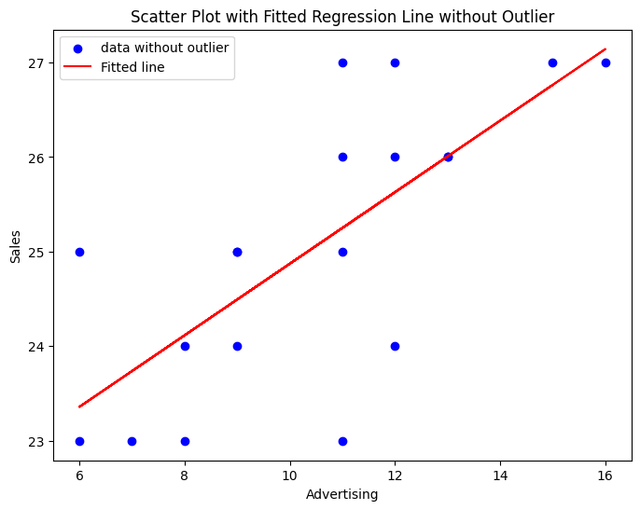

This treatment produces a much better fit, showing the importance of ensuring the the supositions of lineal regression are met. In this case, the variance of the n errors to be fixed.

Removing the outlier improved the variance distribution through the dataset, allowing the model to better fit the data.